Nama : Dema Ghifari Auliansyah

NIM : 1103180033

Kelas : TK-42-PIL

LAB 3 : Supply Chain

ItemManager.sol

//SPDX-License-Identifier: MIT

pragma solidity ^0.8.1;

import "./Allowance.sol";

contract SharedWallet is Allowance {

event MoneySent(address indexed _beneficiary, uint _amount);

event MoneyReceived(address indexed _from, uint _amount);

function withdrawMoney(address payable _to, uint _amount) public ownerOrAllowed(_amount) {

require(_amount <= address(this).balance, "Contract doesn't own enough money");

if(!isOwner()) {

reduceAllowance(msg.sender, _amount);

}

emit MoneySent(_to, _amount);

_to.transfer(_amount);

}

function renounceOwnership() public override onlyOwner {

revert("can't renounceOwnership here"); //not possible with this smart contract

}

receive() external payable {

emit MoneyReceived(msg.sender, msg.value);

}

}

* Mendeploy smart contract
* Smart Contract ItemManager

Pertama kita membutuhkan Smart Contract ItemManager

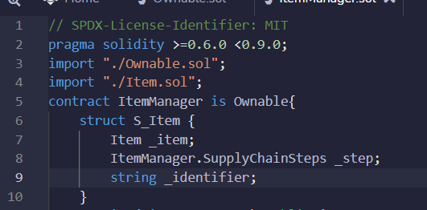

Item.sol

// SPDX-License-Identifier: MIT

pragma solidity >=0.6.0 <0.9.0;

import "./ItemManager.sol";

contract Item {

uint public priceInWei;

uint public paidWei;

uint public index;

ItemManager parentContract;

constructor(ItemManager _parentContract, uint _priceInWei, uint _index) {

priceInWei = _priceInWei;

index = _index;

parentContract = _parentContract;

}

receive() external payable {

require(msg.value == priceInWei, "We don't support partial payments");

require(paidWei == 0, "Item is already paid!");

paidWei += msg.value;

(bool success, ) = address(parentContract).call{value:msg.value}(abi.encodeWithSignature("triggerPayment(uint256)", index));

require(success, "Delivery did not work");

}

fallback () external {

}

}

* Smart Contract Item

Kita akan membuat satu Smart Contract lagi yang bernama Item

Owanable.sol

// SPDX-License-Identifier: MIT

pragma solidity >=0.6.0 <0.9.0;

contract Ownable {

address public _owner;

constructor () {

_owner = msg.sender;

}

/**

* @dev Throws if called by any account other than the owner.

*/

modifier onlyOwner() {

require(isOwner(), "Ownable: caller is not the owner");

_;

}

/**

* @dev Returns true if the caller is the current owner.

*/

function isOwner() public view returns (bool) {

return (msg.sender == _owner);

}

}

* Fungsi kepemilikan

Lalu kita rubah sedikit pada smartcontract “ItemManager” kita dan kita set untuk dapat di eksekusi oleh pemilik saja

* Install Truffle

Untuk meninstall Truffle pada windows, kita menginstal berbasiskan CLI bisa menggunakan Windows Powershell dengan mengetikkan “ npm install -g [npm@8.7.0](mailto:npm@8.7.0) “

Lalu buat folder disini saya menggunakan penamaan “s06-eventtrigger”

Lalu unbox react boxnya

Langkah selanjutnya kita buka text editor kita, disini saya memakai visual studio code. Setelah di buka arahkan ke folder yang kita sudah buat sebelumnya lalu di dalam folder contract hapus file “SimpleStorage.sol”

Setelah mengghapus file “SimpleStorage.sol” kita masukan kontrak kita yang sebelumnya sudah kita siapkan dari remix. Jika ada pesan error maka kita abaikan saja terlebih dahulu.

Setelah itu kita dapat merubah di evoirment kita agar dapat di compile

